# Lesson 10 – B4XPages

* What is a B4XPage
* How to Create and Delete a B4XPage
* Passing Values within Pages

What students should know

**3h**

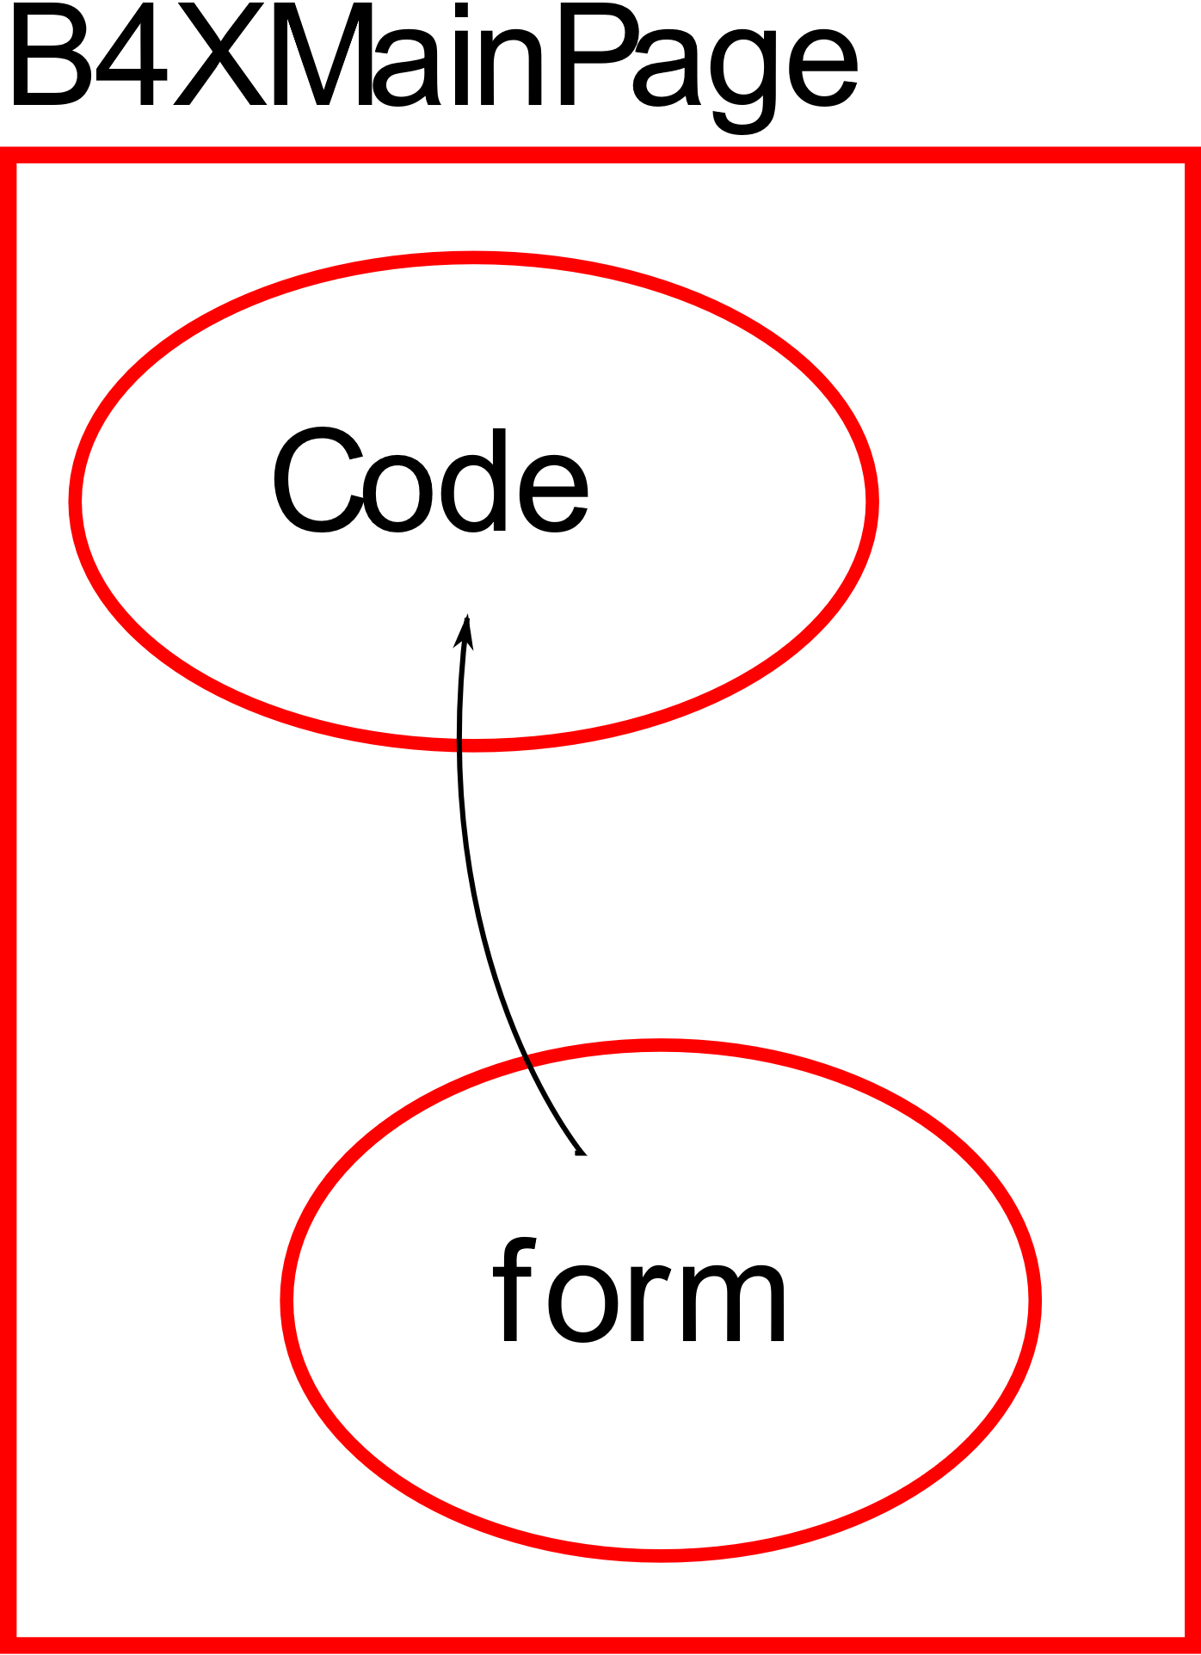B4XPages is a software library. Includes classes and procedures to create multiple application communication forms with the user. Also, it helps to transfer applications to different platforms using the B4A, B4i and B4J tools.

Every application you have created so far with B4J already includes a B4XPage. This is B4XMainPage which is always the user's first contact form with the application. More generally, each B4XPage manages all the codes required for the GUI (Graphics User Interface) to work.

## The structure of an application's folders

When you start a new program with B4XPage, the following folder structure is created.

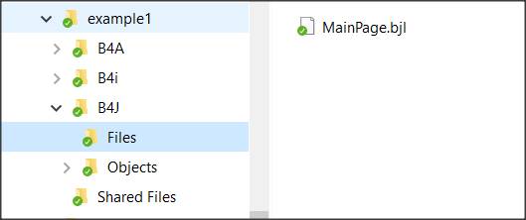Each of the three folders B4A, B4i And B4J include the relevant codes in order to create applicat **MainPage.bjl** ions, Android, Ios computers (Windows, Linux platforms) respectively.

Figure example1 folders

Specifically, in the **B4J** folder there is the “Files” folder where it contains all the files created with the Designer as well as any other files that must be used during the execution of the code e.g. images. **MainPage**.**bjl** is the file that was created automatically during the creation of the application and is its home screen. The Shared Files folder also includes files that the three different applications can share if the developer **chooses** to create an application for both Android, IOS and PC.

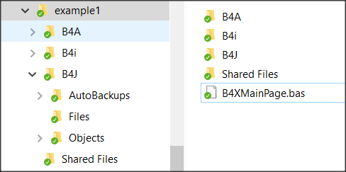The application's home folder contains all the files that create the different B4XPages of our application.

Figure B4XPage files

The first page that is created must have the name **“B4XMainPage.bas”** and cannot be changed; all other pages are named by the developer.

## Starting an application with B4XPage.

When creating a new application with B4Xpage, the language has already prepared the first page and as mentioned its name in the application folder is B4XMainPage.bas. Also, it has created a form (or GUI screen) to communicate with the user (named MainPage.bjl). Eventually, a mechanism called B4XPagesManager undertakes to manage the pages.

**Sub** Class_Globals

**Private** Root **As** **B4XView**

**Private** xui **As** **XUI**

**End Sub**

**Public Sub** Initialize

**End Sub**

**Private Sub** B4XPage_Created (Root1  **As**  **B4XView**)

Root = Root1

Root. LoadLayout("MainPage")

**End Sub**

### What is Root

The Root variable is an object of class B4XView. Undertakes to perform all display-related tasks in the various forms created by the developer (also associated with code sharing in B4J, B4A, B4i). Therefore, the Root object instructs the MainPage form to load with the Root.LoadLayout("MainPage" method).

### Create a new B4XPage

**Step 1.**

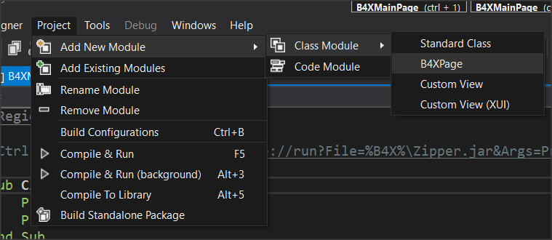After Create an app select from the menu Project – Add New Module – Class Module – B4XPage And Give the name B4XPage1.

Picture Create B4XPage

## 

A class with a name “B4XPage1” will be created, and some necessary codes to get started. The user communication screen (GUI) has not yet been created at this point. This should be done by the Designer later.

**Sub** Class_Globals

**Private** Root  **As**  **B4XView** 'ignore

**Private** xui  **As**  **XUI** 'ignore

**End Sub**

'You can add more parameters here.

**Public Sub** Initialize  **As**  **Object**

**Return Me**

**End Sub**

**Private Sub** B4XPage_Created (Root1  **As**  **B4XView**)

Root = Root1

'load the layout to Root

**End Sub**

Picture The new B4XPage

**Step 2.**

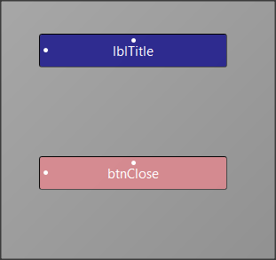Open Designer and from the menu File select New.

Picture Form

From the Variants tab, specify the dimensions of the form you want to design, and then select a label and button to insert into your form as in the Picture 3.

**Step 3.**

Use the menu Generate Members to insert the two objects into your code as well as the Click of the button. Remember that this action must be applied when you are in the code of the B4XPage1.

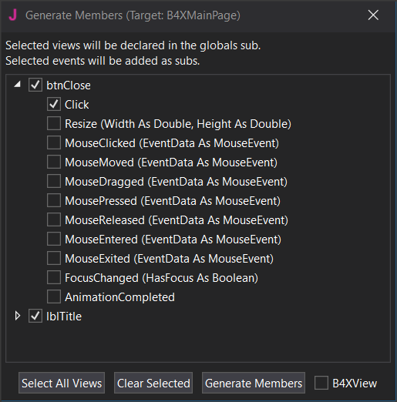

Picture Generate Members

From the file menu save your form named frmPage1. (You can give any name you want, and it serves the needs of the application).

The following code (Picture 5) will now be created, and the file will have been displayed frmPage1.bjl in the folder files.

Picture frmPage1

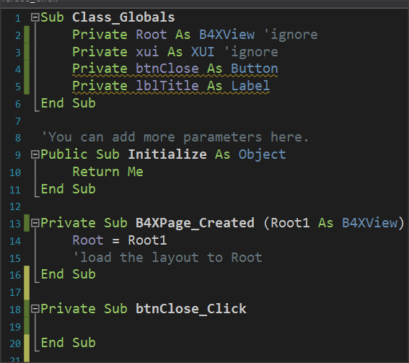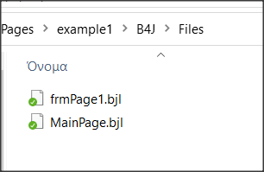

**Step 4.**

To link the form frmPage1 with the B4XPage1 you must now call the property Root.LoadLayout("frmPage1") within the event B4XPage_Created.

**Private Sub** B4XPage_Created (Root1  **As**  **B4XView**)

Root = Root1

'load the layout to Root

Root.LoadLayout(“frmPage1”)

**End Sub**

The next steps include method’s programming and depend on the purpose of the application you are building.

In our example, suppose you want to move to the B4XPage1 screen with one click in B4XmainPage’s button and then click the button you placed to return to the home page.

## Call a new B4Xpage.

Each new B4XPage you create is a class. Therefore, before you can use it, you must create an object based on it. The creation is usually done in the B4XPage that will call the new one. So, in the previous example we write in B4XmainPage (Picture 6):

1. Picture containing text

   Automatically created descriptionSet a class object B4XPage1.

Picture Create B4XPage

1. Initialize page 1. Runs the Initialize routine within class B4XPage1.
2. Create an ID for the new page object. (In the example is "my first Page")
3. Call the new page while the home page remains open.
4. Second way to call a page where the home screen closes and only the new page remains open.

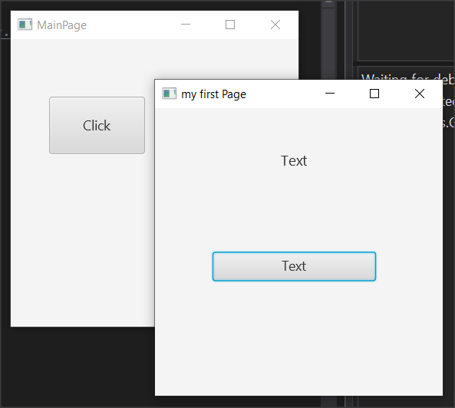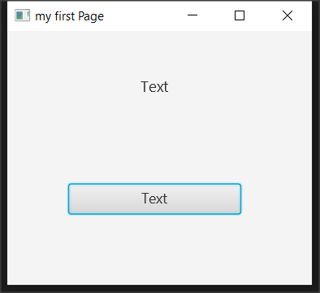

Picture 7 Two methods to open a B4Xpage

## Close a B4XPage.

When a B4XPage is called, the program control passes to that page. Therefore, for the page to close, an event must occur, such as pressing a button or the close button in the top right of the window. More generally, it also depends on how the screen was opened:

|  |  |
| --- | --- |
| **When opened with:** | **Usually closes with:** |
| B4XPages.ShowPage("my first Page") | B4XPages.ClosePage(Me) |
| B4XPages.ShowPageAndRemovePreviousPages("my first Page") | B4XPages.ShowPageAndRemovePreviousPages("MainPage") |

The first way closes the current form while the second way essentially calls the home page again while closing the current one.

## Transfer information between pages

For one page to have access to data from another, those pages must have variables declared with the keyword Public. The pages objects themselves when they are created either in the MainPage or elsewhere have also been declared as Public.

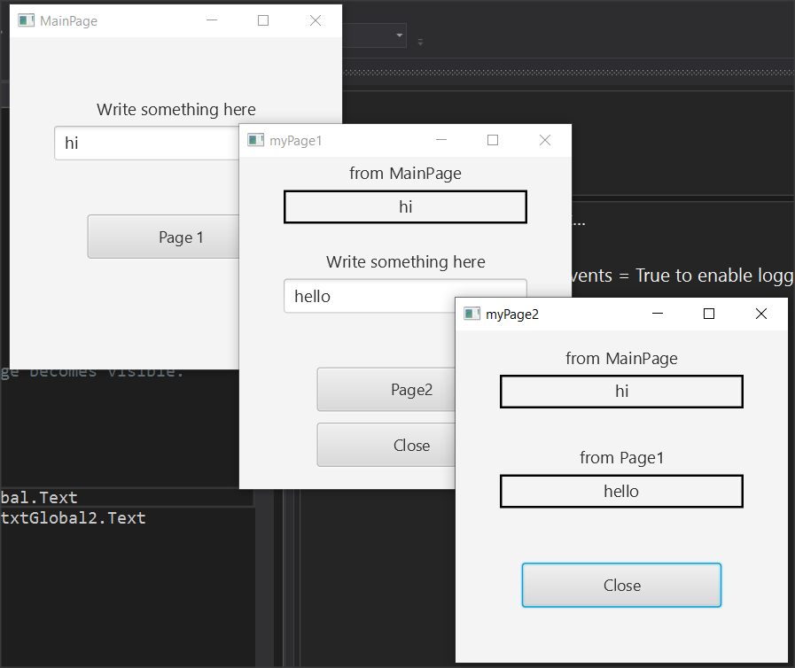

Picture Example 2

**Example 2**

For the purposes of this example, you will use the application of example 2. This includes MainPage, B4XPage1 and B4XPage2. Forms have also been created in the Designer. Open example 2, run it, and observe its operation.



As you run the application, notice that text from textFields is transferred to the following pages. This is because both page1 and page2 and both TextField are declared public.

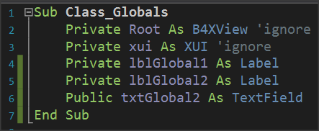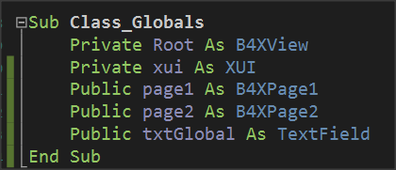

Picture 9 Public declarations in MainPage and Page1

In order page1 to have access to the txtGlobal1 variable, it must also use it by indicating the name of the page on which it was created:

lblGlobal1.Text = **B4XPages.MainPage**.txtGlobal.Text

where lblGlobal1 is a label that displays the content read on the page1 screen.

Similarly, Page2 has access to MainPage's txtGlobal1 and Page1's txtGlobal2 variables as follows:

lblGlobal1.Text = **B4XPages.MainPage**.txtGlobal.Text

lblGlobal2.Text = **B4XPages.MainPage.page1**.txtGlobal2.Text

where lblGlobal1 and lblGlobal2 are two labels that display the contents of the two Public Variables on the page2 screen.

## The Life of B4XPages

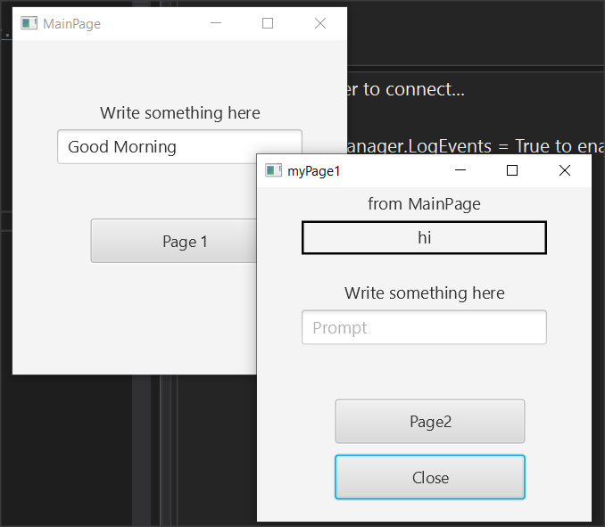In the previous example, try closing all windows except MainPage and type in new text and press the button to page1. You will notice that the value displayed by the MainPage it is not the new but still shows the first one.

Picture B4XPage life

This is because B4Xpages remain in computer memory and each time they are called the event B4XPage_Create does not run again. To read the global variables again from MainPage you can run event **B4XPage_Appear** and in there use the variables from MainPage:

**Private Sub B4XPage_Appear**

lblGlobal1.Text = B4XPages.MainPage.txtGlobal.Text

**End Sub**

Unlike B4XPage_Create that runs only once on the first call of the page, B4XPage_Appear runs every time the window appears in the foreground, so you can use it whenever the page returns to transfer variables from other forms.

## Exercises

1. The little encyclopedia of dogs. Create an application where three different breeds of dogs are displayed on a home page and after the user clicks on the corresponding name display information about the breed along with two photos.

*You can use TextArea in designer to make bigger text areas with scroll bar.*

1. Build an application that solves:
   1. the primary equation ax+b=0,
   2. the secondary equation ax a2+bx+c=0 and
   3. calculates the hypotenuse of a triangle given the dimensions of the two vertical sides.

*It is given that the square root of an x number is calculated by sqrt(x).*

1. Εικόνα που περιέχει κείμενο, τηλεόραση, οθόνη

   Περιγραφή που δημιουργήθηκε αυτόματαBuild an app that creates a virtual store as follows: The home screen will show images of 4 different objects, such as laptops and a TextField for each item where customer writes the quantity. Then pressing the Buy button, the program on a new page displays the Total Value and quantity of items selected. *Except MainPage you will need only one more.*